Kickstarter Crowdfunding Analytics Dashboard
Welcome to the Kickstarter Crowdfunding Dashboard project — a powerful data visualization tool designed to analyze the performance, trends, and insights from Kickstarter crowdfunding campaigns. This interactive dashboard offers a clear and comprehensive overview of project outcomes, funding trends, contributor data, category analysis, and more.
Dataset

Project Description
This project is focused on developing an interactive and data-driven dashboard using Kickstarter’s historical dataset. The aim is to empower stakeholders, researchers, analysts, and campaign organizers with actionable insights into the crowdfunding landscape.
Using visual elements such as pie charts, bar graphs, maps, and slicers, this dashboard brings clarity to complex data and helps in making informed decisions.

Key Features

Summary Metrics
- Total Amount Raised by Successful Projects
- Total Number of Backers for Successful Projects
- Average Duration of Successful Projects

Visual Insights
- Goal Range Distribution – Shows what percentage of successful projects fall within various goal brackets.
- Project Outcomes – Breakdown of project states such as successful, failed, canceled, suspended, etc.
- Category-Based Analysis – Evaluate performance across categories like Tabletop Games, Music, Product Design, and more.
- Geographic Distribution – Projects visualized by country and state using bar charts and maps.
- Top Performing Campaigns – Highlights the projects that raised the highest amounts.

Interactive Filters
- Year, Month, and Quarter Filters – Analyze campaign trends over time.
- State Filter – Drill down into project outcomes like live, failed, successful, etc.
- Country, Category, and Outcome Filters – Dynamic slicing to explore specific segments of data.

Technologies Used
- Excel, Power BI
- Data Cleaning and Modelling
- DAX
- Visual Design Principles for data storytelling

Dataset Description
The dataset includes historical data of Kickstarter campaigns and contains the following key attributes:
- Project Name
- Category
- Goal
- Pledged Amount
- Backers Count
- Country
- State (Success/Failed/Live etc.)
- Launch Date and Deadline
This dataset has been cleaned and transformed for better readability and analysis, ensuring the integrity of the visualizations.

Dashboard Snapshots

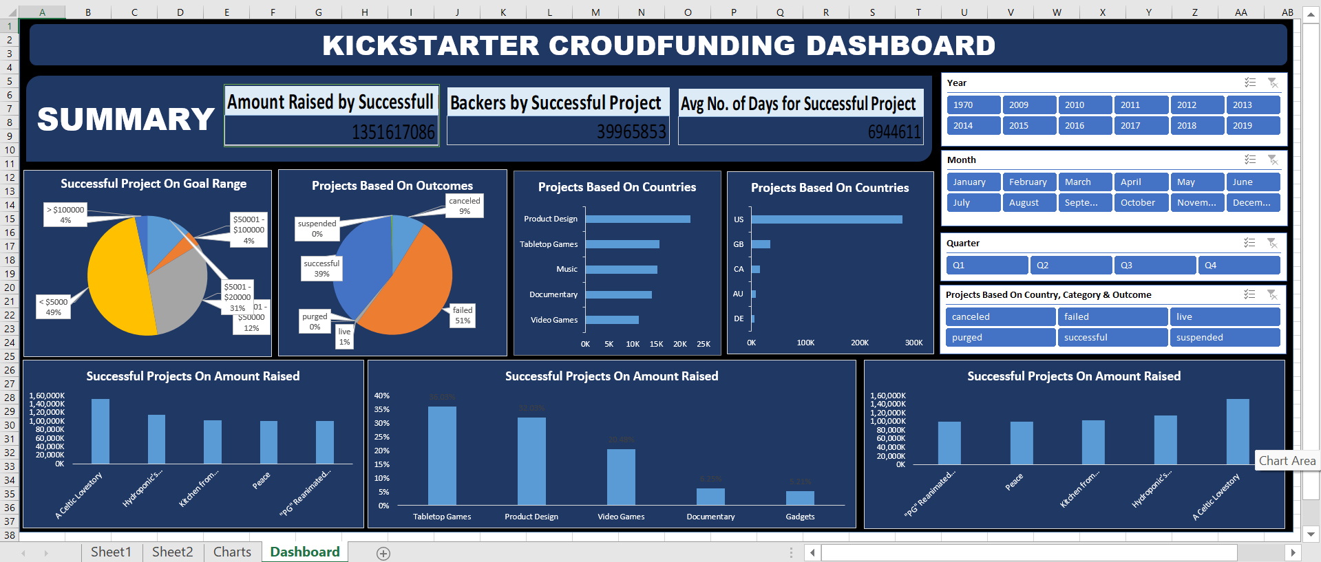

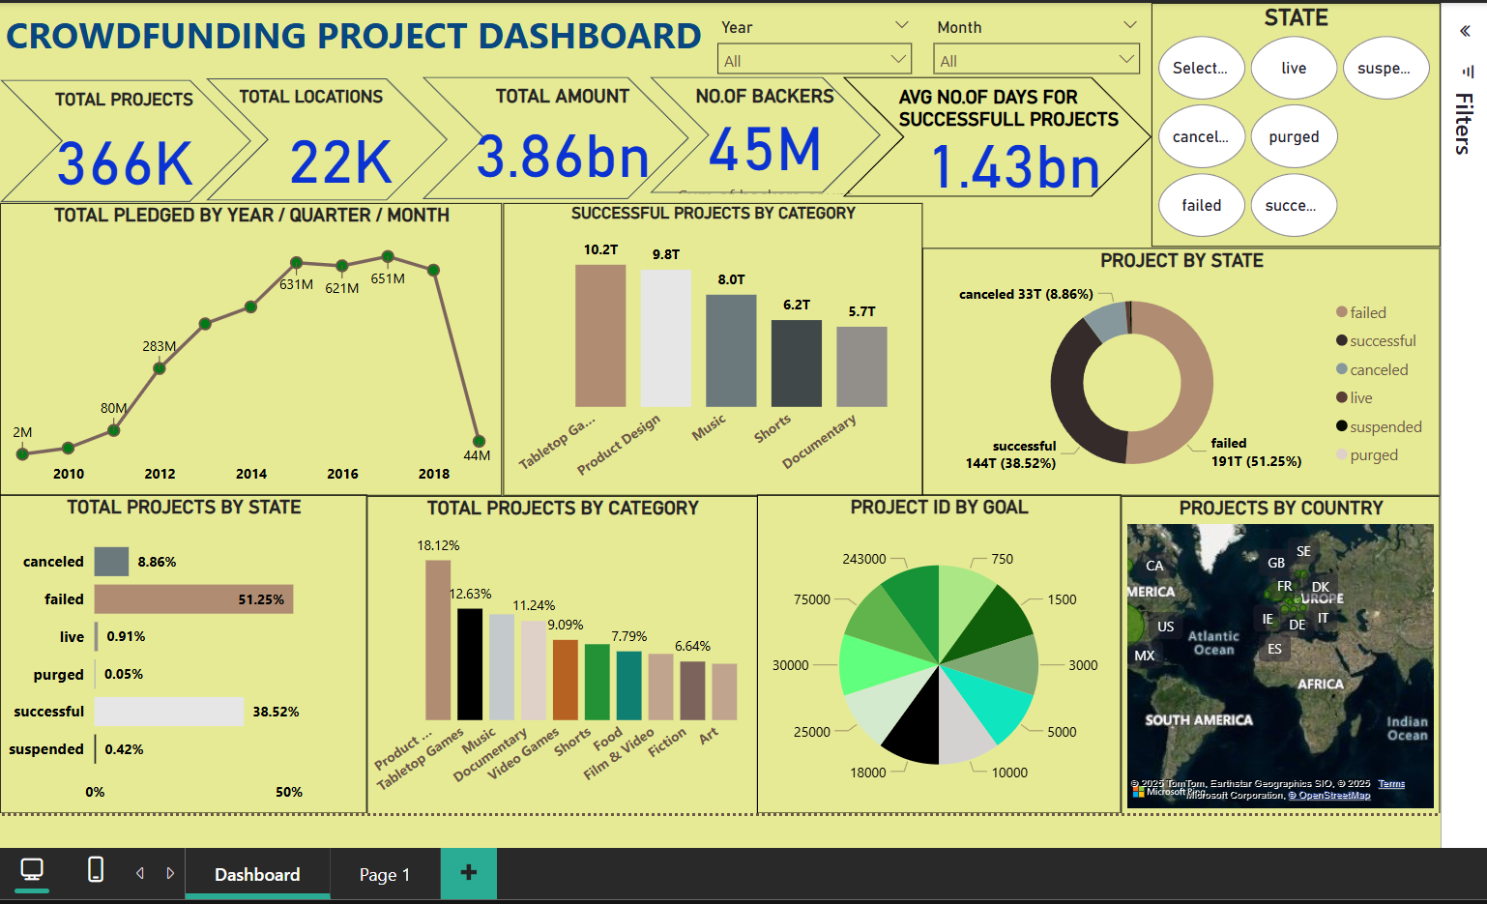

Use Cases
- Strategic planning for new Kickstarter campaigns
- Competitor benchmarking
- Investment decision-making for crowdfunding backers
- Academic research and data analytics projects

How to Use
- Download or clone this repository.
- Open the dashboard file in the respective tool (Excel/Power BI/Tableau).
- Use slicers and filters to interact with the data.
- Explore trends, performance metrics, and category insights.

Insights You Can Derive
- Which countries dominate successful crowdfunding campaigns?
- What funding goal ranges are most achievable?
- Which categories receive the most backers and pledges?
- How has Kickstarter campaign success evolved over time?

Author
Jyoti Gupta
Data Analyst | Student at Vidyalankar School of Information Technology
Linkedin | Email: gjyoti8928@gmail.com

